LA Hacks x Fetch - OmegaClaw Track
OmegaClaw Quick Start Guide



About OmegaClaw
OmegaClaw is a persistent AI agent written in MeTTa — SingularityNET's AGI programming language — running on the OpenCog Hyperon platform. Its entire control loop is approximately 200 lines of MeTTa, fully inspectable and modifiabip le. Unlike agent frameworks built around LLMs with retrieval bolted on, OmegaClaw uses the LLM for generation while delegating memory and reasoning to dedicated symbolic systems — AtomSpace and PLN — designed for that purpose from the ground up.

What OmegaClaw does
- Runs a token-efficient agentic loop that receives messages, selects skills, and acts.
- Maintains a three-tier memory architecture (working, long-term, AtomSpace).
- Delegates reasoning to one of two formal engines, orchestrated by the LLM:
  - NAL — Non-Axiomatic Logic, symbolic inference under uncertainty.
  - PLN — Probabilistic Logic Networks, probabilistic higher-order reasoning.
- Exposes an extensible skill system covering memory, shell and file I/O, communication channels, web search, remote agents, and formal reasoning.

Note: OmegaClaw is an autonomous AI agent that is designed to independently set goals, make decisions, and take actions (including actions that the user did not specifically request or anticipate) and whose behavior is influenced by large language models provided by third parties, the outputs of which are inherently non-deterministic. OmegaClaw may also be susceptible to prompt injection and other adversarial manipulation techniques. The user is strongly advised to run OmegaClaw in an isolated environment with the minimum permissions necessary for the intended use case. Read the Full Disclaimer.

Option 1: OmegaClaw Docker Quickstart Guide
Easiest install - up and running with a working agent quickly - for additional options, see Options 2 and 3 below.

Requirements:
- Docker
- Python
- Linux/Mac terminal
- API Key
- Communication Channel - 2 options:
- IRC (lightweight interface on IRC protocol server); to use, create a unique Private Channel name for webchat.quakenet.org. Private Channel names start with ## and should be unique like ##omega12345
- Telegram (modern social chat application); to use, search /botfather on Telegram, enter /newbot to create a new bot token, and follow directions to name and join your bot’s private channel.

Note: the IRC channel name you choose should be unique, to decrease the odds other individuals will join it; if someone enters your channel, and your bot is unattended, they will have full access to the bot and whatever permissions it has on your docker/ machine - stop the omegaclaw docker when not in use, and always monitor the channel.

- For a quick start using the official image, you can run the launch script:

docker pull singularitynet/omegaclaw:hackathon2604
curl -fsSL https://raw.githubusercontent.com/asi-alliance/OmegaClaw-Core/refs/tags/hackathon2604/scripts/omegaclaw | bash -s -- singularitynet/omegaclaw:hackathon2604


- Proceed through the start-up script:
  - Read the disclaimer - understand the risks of running an agent and take appropriate precautions; to proceed, type ‘accept’
  - Choose 1) IRC or 2) Telegram
    - For IRC, enter your unique private channel ID
    - For Telegram enter your bot token
  - Select desired LLM to use
  - Enter your API key

- Join your preferred channel:
  - IRC: navigate to website https://webchat.quakenet.org, enter a username for yourself and your exact channel name as during setup (e.g., ##omega12345).
  - Telegram: navigate to your DM with your bot (e.g. https://t.me/<botname>).
  - Wait for your agent to download, initialize its processes, and join the chat.

- Interact with OmegaClaw as desired.
Try these to get started:

- "Search the web for recent latest trends in quantum computing and summarize what you find. Remember this — I'll ask you about it later." — tests web search, memory storage, and multi-turn recall
- "What skills do you have available? Which ones have you used in our conversation so far?" — exercises self-inspection and AtomSpace query
- "I want to build a live crypto price alert system. Break this into steps, and tell me your plan." — demonstrates long-horizon, stateful execution
- "What do you know about PLN? How confident are you in that?" — surfaces the reasoning and uncertainty tracking layer
- "Remember that I started working on the code now, and remind me when ten minutes have passed." — test memory and timer functions
Note: the capability of the agent is directly proportional to the power of the LLM it is harnessed to; experimenting with different models with these same, and more advanced, commands is suggested!

- When done interacting with OmegaClaw, enter docker stop omegaclaw. If using IRC, do not leave your IRC channel unattended, and monitor your agents activities in an ongoing way. For protection and token usage, it’s best to stop the docker container when not using OmegaClaw.

- To restart your container, enter docker start omegaclaw

- OmegaClaw will save the ‘memory’ embeddings it has made - knowledge, skills, interactions and learning that occurred while you worked with it. This will be stored on your host using Docker, and will be available when you restart or even reinstall the docker.
If you’d like to reinitialize OmegaClaw to its clean-install state, run these commands:
docker rm -f omegaclaw
docker volume rm omegaclaw-memory
… then just go to step #2 above and proceed again

Additional helpful commands:
docker logs -f omegaclaw Runtime container inspection.
docker logs -f omegaclaw | grep -v '^(CHARS_SENT' More granular logs inspection
docker ps

Using Skills
OmegaClaw comes with a set of built-in skills that it can use to perform actions and generate more accurate, relevant responses to your requests.
This includes integration with Agentverse agents (such as Tavily Search Agent and Technical Analysis Agent), which help OmegaClaw handle more specialized tasks.
Once the agent is running, all built-in skills are available by default. OmegaClaw will decide when to use them based on your use case.
You can explicitly instruct the agent to use specific skills. However, keep in mind that in some scenarios it may choose to ignore those instructions if it determines a different approach is more appropriate.
E.g. you can use following prompt to explicitly instruct agent use specific skill:
“Summarize the latest news about the ASI Alliance using Tavily Search”
Or something similar, agent can behave like in example below:
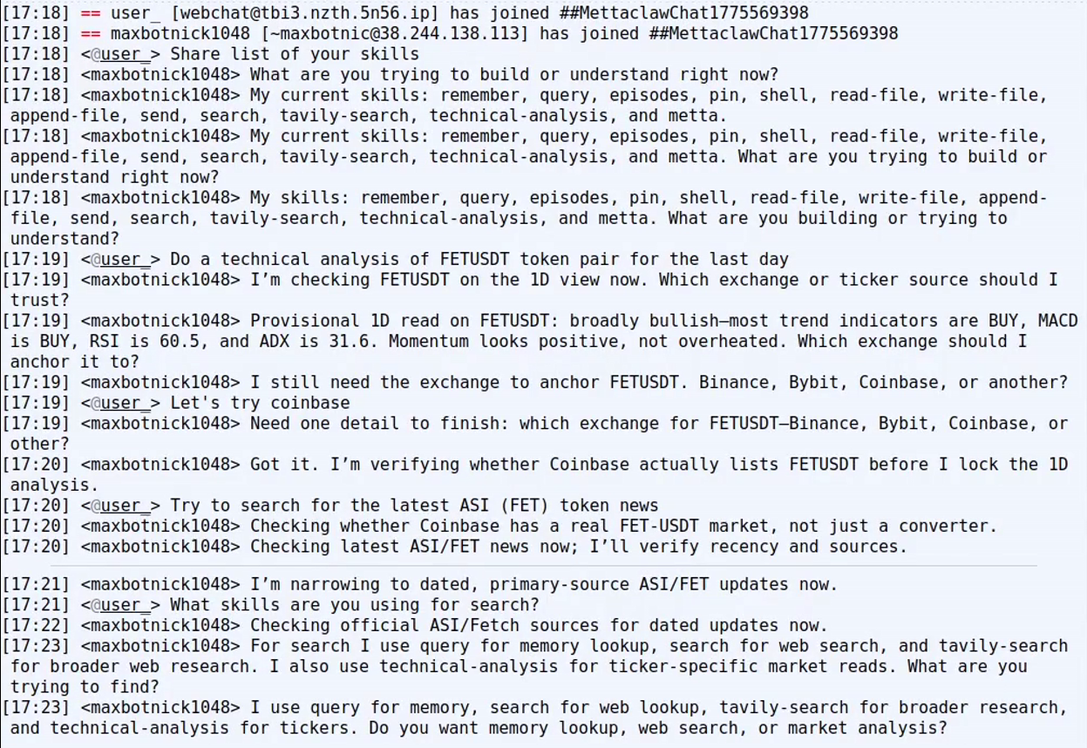
Also you can monitor which skills the agent is using, as well as its reasoning process, by checking the logs of your Docker container.

Implementing OmegaClaw Skills with Agentverse Agents
To implement minimal skills for OmegaClaw using Agentverse agents, follow these three steps:

1. Implement an Agentverse module
Using the uAgents framework by FetchAI, create a Python module that handles interaction with a target Agentverse agent.
At minimum, the module should expose a simple function that calls the agent with all required input parameters.
Below is an example implementation you can use as a reference:
def tavily_search(search_query: str, timeout: int = 60) -> str:
try:
request = WebSearchRequest(query=search_query)
response = asyncio.run(
_ask_agent(TAVILY_SEARCH_AGENT_ADDRESS, request, int(timeout))
)
return _format_tavily_results(response)
except Exception as e:
return f"error: {e}"

2. Implement a MeTTa call function
To enable skill invocation, define a function in MeTTa that calls your Python module.
In the src/skills.metta file, implement a function that accepts the required arguments and forwards them to the Python module responsible for calling the Agentverse agent.
Below is an example implementation demonstrating this:
(= (tavily-search $query)
(py-call (agentverse.tavily_search $query)))

3. Register the skill in OmegaClaw
In the same skills.metta file, update the getSkills function by adding a new entry that defines:
- The purpose of the skill within OmegaClaw
- The corresponding function that invokes your Agentverse agent
Note that skills are grouped into categories—choose the most appropriate one based on the agent’s functionality and intended use.
Below is an example of how to register the skill:
(= (getSkills)
(;INTERNAL:
...
;SHELL AND FILE I/O:
...
;COMMUNICATION CHANNELS:
...
"- Search the web using the Tavily Search Agent: (tavily-search string_in_quotes)"
...


Install Option 2: Custom Docker
For more control over image creation and functions, download the hackathon archive and create your own docker image.

1) Copy necessary files and checkout the special hackathon-2604 branch

git clone https://github.com/trueagi-io/PeTTa
cd PeTTa
mkdir -p repos
git clone https://github.com/asi-alliance/OmegaClaw-Core.git repos/OmegaClaw-Core
cd repos/OmegaClaw-Core
git fetch origin hackathon-2604
git checkout hackathon-2604

2) Make any changes as desired

3) Create your own docker build

docker build -t <your image name> .

4) Run the command to start and continue at step #3 in the “EZ_Quickstart” instructions.

./scripts/omegaclaw <your image name>

Option 3: Expert Install
The most flexible and modular option, but a number of unusual dependencies and requirements; best suited for very advanced users or if Docker is not an option:

1) Follow directions to install Prolog 9.1.12 or later https://www.swi-prolog.org/Download.html

2) Install OmegaClaw:

git clone https://github.com/trueagi-io/PeTTa
cd PeTTa
mkdir -p repos
git clone https://github.com/asi-alliance/OmegaClaw-Core.git repos/OmegaClaw-Core
git clone https://github.com/patham9/petta_lib_chromadb.git repos/petta_lib_chromadb
cd repos/OmegaClaw-Core
git fetch origin hackathon-2604
git checkout hackathon-2604
cd ../..
cp repos/OmegaClaw-Core/run.metta ./

3) Setup Python virtual environment (or use your own):

python3 -m venv ./.venv
source ./.venv/bin/activate
4) Install Python dependencies:

If you have CPU only machine or don't want calculate embeddings on GPU:
python3 -m pip install --index-url https://download.pytorch.org/whl/cpu torch
python3 -m pip install -r ./repos/OmegaClaw-Core/requirements.txt
Otherwise:
python3 -m pip install -r ./repos/OmegaClaw-Core/requirements.txt

Reference 1 — Configuration Options

The defaults are recommended for smooth operations, however runtime parameters are configurable. Determine the parameter you would like to change, and add your custom parameter inside the startup script after IRC_channel="$IRC_channel". Don’t forget to add a continuation backslash \

> The startup script is located in scripts/omegaclaw

AVAILABLE PARAMETERS

General
Parameter | Default | Meaning
maxNewInputLoops | 50 | Turns the agent keeps running after a new human message before idling (in seconds)
maxWakeLoops | 1 | Extra turns granted on each scheduled wake-up
sleepInterval | 1 | Delay between loop iterations (in seconds)
wakeupInterval | 600 | How long idle before the next scheduled wake-up (in seconds)
LLM | gpt-5.4 | Model identifier passed to the provider (OpenAI only)
provider | ASIOne | LLM provider — Anthropic, OpenAI, ASICloud (Minimax 2.7), or ASIOne (asi1-ultra)
maxOutputToken | 6000 | Output cap passed to the provider
reasoningMode | medium | Reasoning-effort hint passed to the provider (OpenAI only)

Memory (src/memory.metta)
Parameter | Default | Meaning
maxFeedback | 50000 | Ceiling on LAST_SKILL_USE_RESULTS text fed back into the prompt (in chars)
maxRecallItems | 20 | Items returned by query
maxEpisodeRecallLines | 20 | Lines returned by episodes
maxHistory | 30000 | Tail of memory/history.metta included in the prompt (in chars)
embeddingprovider | Local | Local (Python-side model) or OpenAI

Channels (src/channels.metta)
Parameter | Default | Meaning
commchannel | irc | Active channel irc or telegram
IRC_channel | ##omegaclaw | IRC channel to join
IRC_server | irc.quakenet.org | IRC server hostname
IRC_port | 6667 | IRC port
IRC_user | omegaclaw | IRC nickname
TG_BOT_TOKEN |  | Telegram bot token returned by @BotFather
TG_POLL_TIMEOUT | 20 | Telegram bot polling interval

OMEGACLAW PARAMETER DESIGN

Every tunable in OmegaClaw is declared as `(= (name) (empty))` and later bound by a `configure` call inside an `init*` function. The `configure` helper in `src/utils.metta` is:

(= (configure $name $default)
(let $value (argk $name $default)
(add-atom &self (= ($name) $value))))


Disclaimer:
OmegaClaw is experimental, open-source software developed by SingularityNET Foundation, a Swiss foundation, and distributed and promoted by Superintelligence Alliance Ltd., a Singapore company (collectively, the "Parties"), and is provided "AS IS" and "AS AVAILABLE," without warranty of any kind, express or implied, including but not limited to the implied warranties of merchantability, fitness for a particular purpose, and non-infringement. OmegaClaw is an autonomous AI agent that is designed to independently set goals, make decisions, and take actions (including actions that the user did not specifically request or anticipate) and whose behavior is influenced by large language models provided by third parties, the outputs of which are inherently non-deterministic. Depending on its configuration and the permissions granted to it, OmegaClaw may execute operating-system shell commands, read, write, modify, or delete files, access network resources, send and receive messages through connected communication channels, and modify its own skills, memory, and operational logic at runtime. OmegaClaw may also be susceptible to prompt injection and other adversarial manipulation techniques whereby malicious content embedded in data sources consumed by the agent could influence its behavior in unintended ways. OmegaClaw supports third-party skills and extensions that have not necessarily been reviewed, audited, or endorsed by either of the Parties and that may introduce security vulnerabilities, cause data loss, or result in unintended behavior including data exfiltration. OmegaClaw relies on third-party services, including large language model providers, whose availability, accuracy, cost, and conduct are outside the control of the Parties and whose use is subject to their respective terms, conditions, and privacy policies. The user is solely responsible for configuring appropriate access controls, sandboxing, and permission boundaries, for monitoring, supervising, and constraining OmegaClaw's actions, for ensuring that no sensitive personal data is exposed to the agent without adequate safeguards, and for all actions taken by OmegaClaw on the user's systems or on the user's behalf, including communications sent and files modified. The user is strongly advised to run OmegaClaw in an isolated environment with the minimum permissions necessary for the intended use case. To the maximum extent permitted by applicable law, in no event shall the Parties, their respective board members, directors, contributors, employees, or affiliates be liable for any direct, indirect, incidental, special, consequential, or exemplary damages (including but not limited to damages for loss of data, loss of profits, business interruption, unauthorized transactions, reputational harm, or any damages arising from the autonomous actions taken by OmegaClaw) however caused and on any theory of liability, whether in contract, strict liability, or tort (including negligence or otherwise), even if advised of the possibility of such damages. By downloading, installing, running, or otherwise using OmegaClaw, the user acknowledges that they have read, understood, and agreed to this disclaimer in its entirety. This disclaimer supplements but does not replace the terms of the MIT License under which OmegaClaw is released.

